DEPARTMENT OF APEX INSTITUTE OF TECHNOLOGY

# PROJECTPROPOSAL

## 1. Project Title: - AI based Chatbot to answer FAQs

## 2. Project Scope: -

This project proposal is focusing on creating a chatbot to be used by students to get their

queries responded easily from the university website. The College Enquiry Chatbot has the

role to make pleasant conversations; answer the course and faculty details; give the

link for the academic calendar; answer the regularly asked questions; compute the fees

based on the student's input; and give the timings, address, contacts, and events information of the sectors like Union, Library, IPGE, and AIRC. To build the chatbot, Microsoft Azure bot service as well as Microsoft cognitive services, namely, Text Analytics and LUIS are used.

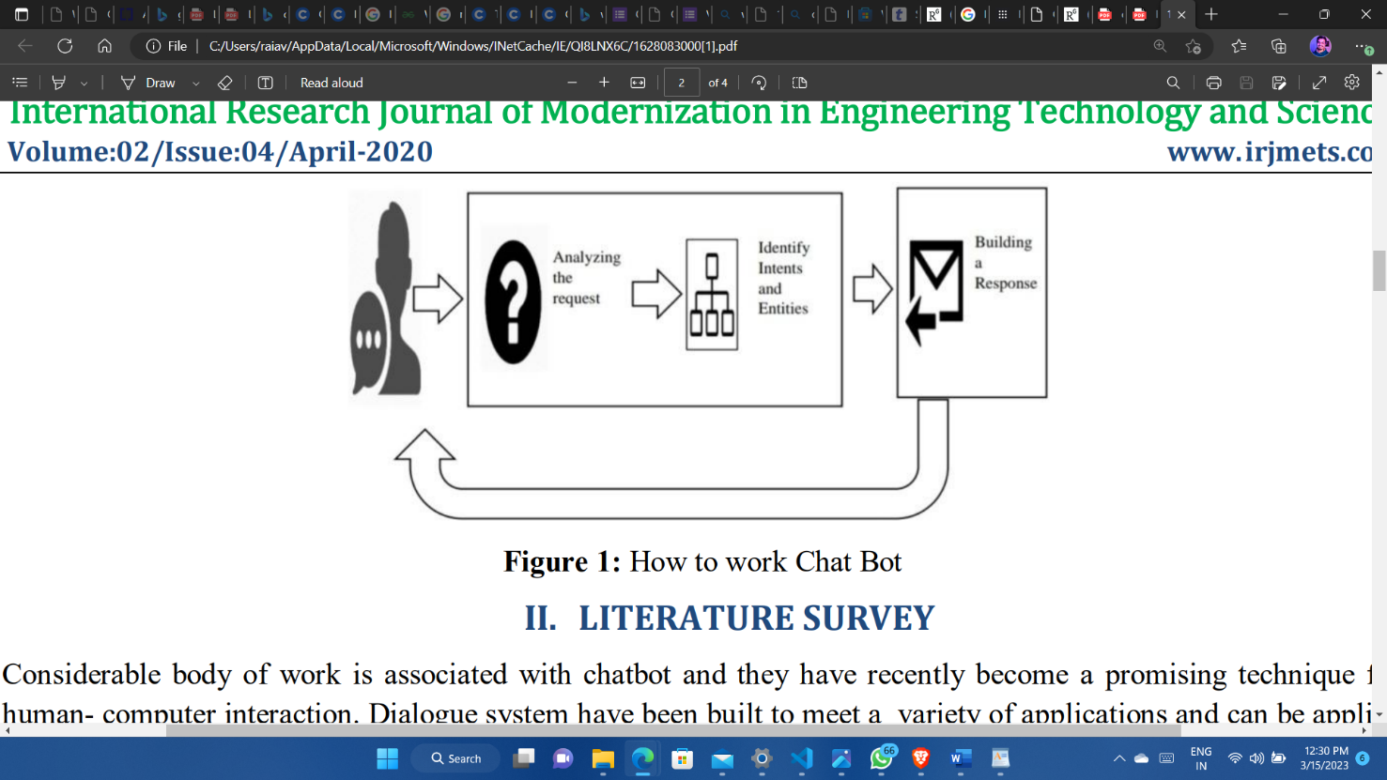A chatbot is a program which can do real conversations with textual and/or auditory methods. Using Artificial Intelligence (AI), chatbots can simulate human conversations. There are two categories of chatbots. One category is command based chatbots where chatbots rely on a databank of replies and heuristics. The user must be very specific while asking the questions so that the bot can answer. Hence, these bots can answer limited set of questions and cannot perform function outside of the code. The other category is chatbots based on Al or machine learning algorithms, these bots can answer ambiguous questions which means the user do not have to be specific while asking questions. Thus, these bots create replies for the user's queries using Natural Language Processing (NLP).

Figure 1 shows how a chatbot works. Whenever a user asks any query, the bot will first investigate the application, then finds intents and units, builds an answer and sends it back to the user. Now, intents mean intention of the query and entity means details of that query. For example. if a student wants to know the office hours of a faculty then the intent will be office hours and entity will be name of the faculty in this case.

Al-powered chatbots are motivated by the need of traditional websites to provide a chat facility where a bot is required to be able to chat with user and solve queries. When live agent can handle only two to three operations at a time, chatbots can operate without an upper limit which really scales up the operations. Also, if any school or business is receiving lots of queries, having a chatbot on a website takes off the load from support team.

Having a chatbot clearly improves the response rate compared to human support team. In addition, since millennials prefer live chats over a phone call, they find a chatbot, which provide a highly interactive marketing platform, very attractive. Furthermore, a chatbot can automate the repetitive tasks. There can be some scenarios where a business or school receives same queries in a day for many times and support team must respond to each query repetitively. Lastly, the most important advantage of having a chatbot is that it is available 24/7. No matter what time it is, a user can get a query solved. All these advantages of a chatbot constitute the motivation to implement a University Enquiry Chatbot

## 3. Requirements: -

* Hardware Requirements

1. Computer or Laptop
2. SDD/HDD
3. Bandwidth

* Software Requirements

1. Development Software

2. Database

3. Cloud base service

**STUDENTS DETAILS**

|  |  |  |
| --- | --- | --- |
| **Name** | **UID** | **Signature** |
| **Avanish Rai** | **20BCS8812** |  |
| **Priyanshu Singh** | **20BCS6896** |  |
|  |  |  |
|  |  |  |
|  |  |  |

**APPROVAL AND AUTHORITY TO PROCEED**

We approve the project as described above, and authorize the team to proceed.

|  |  |  |
| --- | --- | --- |
| **Name** | **Title** | **Signature**  **(With Date)** |
|  |  |  |